AIRPORT FLIGHT LOOKUP SYSTEM USING
BINARY SEARCH

Problem Statement
Airport management systems store thousands of flight records. Efficient retrieval of flight information is necessary to provide quick assistance to passengers. To analyze how Binary Search improves the efficiency of searching flight records in an airport management system and implement the algorithm using Python.

Introduction
Binary Search is an efficient searching algorithm that works on sorted data by repeatedly dividing the search space into two halves. Airport management systems store thousands of flight records. Efficient retrieval of flight information is necessary to provide quick assistance to passengers. To analyze how Binary Search improves the efficiency of searching flight records in an airport management system and implement the algorithm using Python.

Requirements
- Flight records must be sorted.
- Fast response time is required.
- Suitable for large datasets.
- Supports random access.

Algorithm
Step 1: Initialize low and high.
Step 2: Find the middle element.
Step 3: Compare the target with the middle element.
Step 4: Search the left or right half accordingly. Step 5: Repeat until found or search ends.

Program
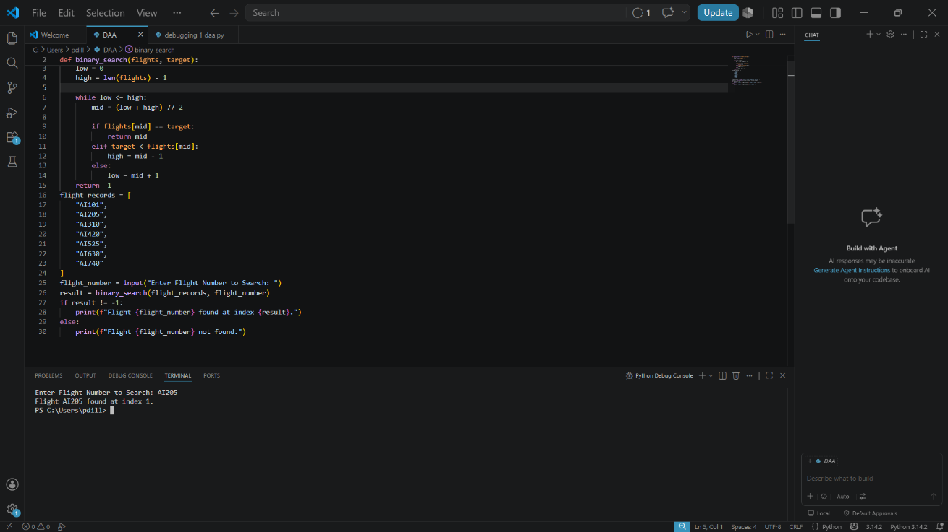

Input
AI525

Advantages
- Faster than Linear Search.
- Reduces passenger waiting time.
- Suitable for large databases.
- Improves airport service efficiency.

10. Conclusion
Binary Search reduces search complexity from O(n) to O(log n), making it ideal for airport flight lookup systems.

Time Complexity Analysis
Case | Time Complexity
Best Case | O(1)
Average Case | O(log n)
Worst Case | O(log n)

